Week 8 GitHub Practice

Robert Brenckman
Charter Oak State College
ITE 215: Software Develop Method & Languages
COSC_ITE215012526FACR
John Rusnak
12/07/2025

Clone
The repo has been cloned to the local pc:
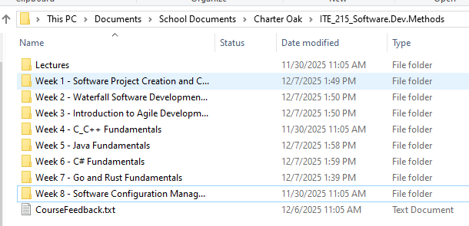

Project
The project I’ve selected is simply uploading the various coursework I’ve performed during this session. I created a branch for ITE215 and ITE217. I then merged in ITE215. To keep the commit history clean, I created another branch based off main that includes the Week 8 portions of the assignment.

Commits and Pushing
My preferred GitHub tool is GitHub Desktop, though occasionally I have to delve into Git-GUI for some more complex operations.
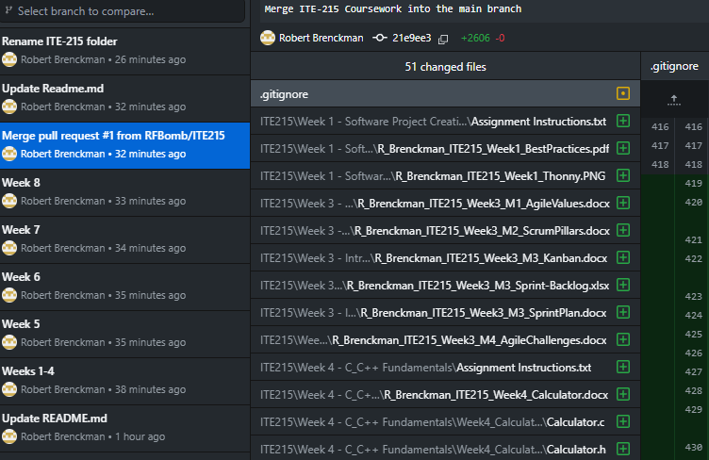

Pull Request

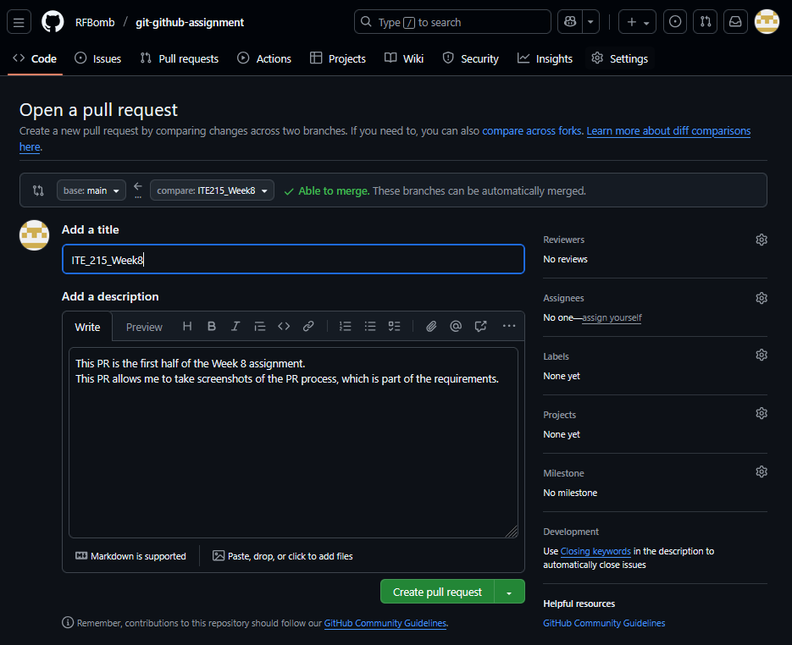
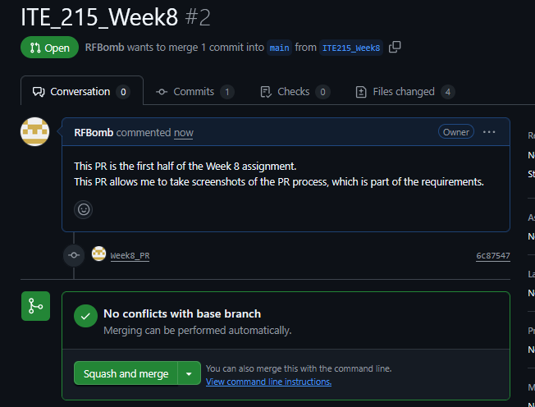
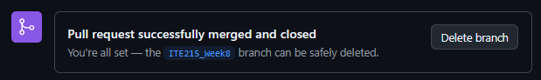

Fetch Changes
This screenshot was taken after changes were fetched from the PR
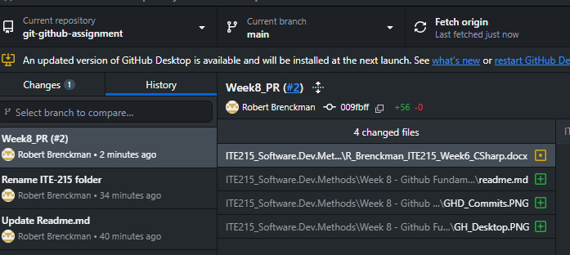
Note that the ‘Current Branch’ is main in above screenshot, and that the commit has a ‘#2’ in it to denote that it was PR #2. In contrast, the below screenshot is from the originating branch:
